# Instructional Guide to Support 2023 Grade 1 Mathematics *Standards of Learning*



Copyright © 2025

by the

Virginia Department of Education

P.O. Box 2120

Richmond, Virginia 23218-2120

[http://www.doe.virginia.gov](http://doe.virginia.gov/)

All rights reserved. Reproduction of these materials for instructional purposes in public school classrooms in Virginia is permitted.

**Superintendent of Public Instruction**

Emily Anne Gullickson, M.Ed. J.D.

**Office of Math and Science**

Dr. Anne Petersen, Director of Math and Science

Dr. Angela Byrd-Wright, Director of Humanities (Former Mathematics Coordinator)

Ms. Victoria Bohidar, Mathematics Coordinator

Dr. Jessica Brown, Elementary Mathematics Specialist

Dr. Regina Mitchell, Mathematics and Special Education Specialist

Mrs. Donna Snyder, Mathematics Division Support Specialist

**NOTICE**

The Virginia Department of Education does not unlawfully discriminate on the basis of race, color, sex, national origin, age, or disability in employment or in its educational programs or services.

Table of Contents

Introduction 2

Understanding the Standard 2

Skills in Practice 2

Concepts and Connections 2

Number and Number Sense 3

1.NS.1 3

1.NS.2 9

1.NS.3 12

Computation and Estimation 16

1.CE.1 16

Measurement and Geometry 25

1.MG.1 25

1.MG.2 30

1.MG.3 34

Probability and Statistics 37

1.PS.1 37

Patterns, Functions, and Algebra 44

1.PFA.1 44

## Introduction

The Mathematics Instructional Guide, a companion document to the 2023 Mathematics *Standards of Learning*, amplifies the Standards of Learning by defining the core knowledge and skills in practice, supporting teachers and their instruction, and serving to transition classroom instruction from the 2016 *Mathematics Standards of Learning* to the newly adopted 2023 Mathematics *Standards of Learning.* Instructional supports are accessible in #GoOpenVA and support the decisions local school divisions must make concerning local curriculum development and how best to help students meet the goals of the standards. The local curriculum should include a variety of information sources, readings, learning experiences, and forms of assessment selected at the local level to create a rigorous instructional program.

For a complete list of the changes by standard, the [2023 Virginia Mathematics *Standards of Learning – Overview of Revisions*](https://www.doe.virginia.gov/home/showpublisheddocument/49329/638325360068970000) is available and delineates in greater specificity the changes for each grade level and course.

The Instructional Guide is divided into three sections: Understanding the Standard, Skills in Practice, and Concepts and Connections aligned to the Standard. The purpose of each is explained below.

### Understanding the Standard

This section includes mathematics understandings and key concepts that assist teachers in planning standards-focused instruction. The statements may provide definitions, explanations, or examples regarding information sources that support the content. They describe what students should know (core knowledge) as a result of the instruction specific to the course/grade level and include evidence-based practices to approaching the Standard. There are also possible misconceptions and common student errors for each standard to help teachers plan their instruction.

### Skills in Practice

This section outlines supporting questions and skills that are specifically linked to the standard. They frame student inquiry, promote critical thinking, and assist in learning transfer. Curriculum writers and teachers should use them to plan instruction to deepen understanding of the broader unit and course objectives. This is not meant to be an exhaustive list of student expectations.

### Concepts and Connections

This section outlines concepts that transcend grade levels and thread through the K through 12 mathematicsprogram as appropriate at each level. Concept connections reflect connections to prior grade-level concepts as content and practices build within the discipline as well as potential connections across disciplines.

# Grade 1

## Number and Number Sense

In K-12 mathematics, numbers and number sense form the foundation building blocks for mathematics understanding. Students develop a foundational understanding of numbers, their properties, and the relationships between them as they learn to compare and order numbers, understand place value, and perform numerical operations. Number sense includes an understanding of patterns and the relationships between numbers and being able to apply this knowledge to real world problems. Throughout K-12, students build on their number sense to develop a deeper understanding of mathematical concepts and reasoning.

In Grade 1, students develop a sense of quantity that allows them to see relationships between numbers, think flexibly about numbers, and notice patterns that can emerge as they work with numbers to quantify, measure, and make decisions in life. At this grade level, students will use flexible counting strategies to determine and describe quantities up to 120; represent, compare, and order quantities up to 120; and use mathematical reasoning and justification to solve contextual problems that involve partitioning models into two and four equal-sized parts.

### 1.NS.1

##### The student will utilize flexible counting strategies to determine and describe quantities up to 120.

1. Students will demonstrate the following Knowledge and Skills:
2. Count forward orally by ones from 0 to 120 starting at any number between 0 and 120.
3. Count backward orally by ones when given any number between 1 and 30.
4. Represent forward counting patterns when counting by groups of 5 and groups of 10 up to 120 using a variety of tools (e.g., objects, coins, 120 chart).
5. Represent forward counting patterns when counting by groups of 2 up to at least 30 using a variety of tools (e.g., beaded number strings, number paths [a prelude to number lines], 120 chart).
6. Group a collection of up to 120 objects into tens and ones, and count to determine the total (e.g., 5 groups of ten and 6 ones is equal to 56 total objects).
7. Identify a penny, nickel, and dime by their attributes and describe the number of pennies equivalent to a nickel and a dime.
8. Count by ones, fives, or tens to determine the value of a collection of like coins (pennies, nickels, or dimes), whose total value is 100 cents or less.

###### Understanding the Standard

* The natural numbers are 1, 2, 3, 4…. The whole numbers are 0, 1, 2, 3, 4…. Students should count the whole numbers 0, 1, 2, 3, 4….
* There are three developmental levels of counting:
  + rote sequence;
  + one-to-one correspondence; and
  + the cardinality of numbers.
* Counting involves two separate skills: verbalizing the list (rote sequence counting) of standard number words in order (“one, two, three, …”) and connecting this sequence with the objects in the set being counted, using one-to-one correspondence. The association of number words with collections of objects is achieved by moving, touching, or pointing to objects as the number words are spoken. Objects may be presented in random order or arranged for easy counting. Objects for counting may be arranged in various configurations including in a line, in a rectangular array, in a circle, or in a scattered formation.
* If a set is empty, it has zero objects or elements. Zero is both a number and a digit. It is used as a placeholder in our number system.
* Cardinality is knowing how many are in a set by recognizing that the last counting word tells the total number in a set. Once a student has counted a collection of objects, the teacher may be able to assess whether the student has cardinality of number by asking the question, “How many are there?” Students who do not yet have cardinality of number are often unable to tell you how many objects there were in the collection without recounting them.
* Rote counting is a prerequisite skill for the understanding of addition (one more), subtraction (one less), and the ten-to-one concept of place value.
* Conservation of number is applied when students understand that a group of 10 objects is still 10 objects regardless of whether they are arranged in a cup, group, row, stack, etc.
* Counting forward and backward leads to the development of counting on and counting back.
* Counting forward by rote, supported by visuals such as the hundreds chart or number path, advances children’s development of sequencing.
* A number path is a counting model where each number is represented within a rectangle and can be counted. An example of a number path is shown below:

|  |  |  |  |  |  |  |  |  |  |
| --- | --- | --- | --- | --- | --- | --- | --- | --- | --- |
| 1 | 2 | 3 | 4 | 5 | 6 | 7 | 8 | 9 | 10 |

* A number line is a length model where each number represents its length (distance) from zero. When young children use a number line as a counting tool, they often confuse what should be counted (the numbers or the spaces between the numbers). A number path is more appropriate for students at this age. An example of a number line is shown below:



* Counting backward by rote lays the foundation for subtraction. Students in Grade 1 should count backward beginning with 30, 29, 28… through …3, 2, 1, 0.
* The patterns developed when skip counting are precursors for recognizing numeric patterns, functional relationships, and concepts underlying money, time, and multiplication.
* Skip counting by twos supports the development of the concept of even numbers and the development of multiplication facts for two.
* Skip counting by fives lays the foundation for telling time to the nearest five minutes, counting money, and developing the multiplication facts for five.
* Skip counting by tens is a precursor for place value, addition (10 more), subtraction (10 less), counting money, and developing the multiplication facts for ten.
* Calculators can be used to display the numerical patterns resulting from skip counting. The constant feature of the four-function calculator can be used to display the numbers in the sequence when skip counting by that constant.
* Unitizing is the concept that a group of objects can be counted as one unit (e.g., 10 ones can be counted as 1 ten).
* The number system is based on a pattern of tens where each place has 10 times the value of the place to its right. This is known as the ten-to-one concept of place value.
* Using objects and asking questions such as, “How many are in each group?” or “How many groups are there?” and” What is the total number you have?” supports students as they learn to skip count and helps to solidify their understanding of cardinality and assists in developing multiplicative reasoning.
* Manipulatives that can be physically connected and separated into groups of tens and leftover ones, such as connecting or snap cubes, beans on craft sticks, pennies in cups, bundles of sticks, or beads on pipe cleaners should be used. Ten-to-one trading activities with manipulatives on place value mats, including base 10 blocks, are more appropriate in Grade 2.
* Frequent and varied experiences with coins help students develop an understanding of money and gain an awareness of consumer skills and the use of money in everyday life:
  + counting collections of pennies (practicing one-to-one correspondence);
  + drawing pennies to show the value of a given coin (e.g., nickel, dime);
  + physically manipulating coins and making comparisons about their sizes, colors, and values;
  + playing store and purchasing classroom objects, using play money;
  + using skip counting to count a collection of like coins;
  + representing the value of coins using a variety of organizers, such as five/ten frames, hundreds charts, or pictures; and
  + trading the equivalent value of pennies for a nickel or a dime, using play money.
* Counting coins is an application of unitizing. Unitizing is the concept that a group of objects can be counted as one unit (e.g., 10 pennies can be counted as 1 dime).
* It is important to develop the concept that a nickel has a value of five cents (which is the same as five pennies), and that a dime has a value of 10 cents (which is the same as ten pennies), even though each coin (nickel or dime) is only one object. Manipulatives such as ten frames, hundreds charts, or cube stacks can be used to show the value of each coin.

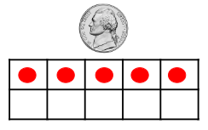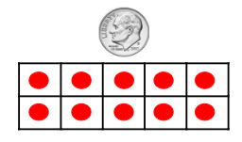

* A variety of classroom experiences in which students manipulate physical models of money and count forward to determine the value of a collection of coins are important activities to develop competence with counting money.

###### Skills in Practice

While the five process goals are expected to be embedded in each standard, the Skills in Practice highlight the most prevalent process goals in relation to the content presented.

**Mathematical Communication:** As students develop their counting skills, some students may struggle to accurately count to 120. For example, students may have difficulty crossing over a decade (from 29 to 30 or from 59 to 60), or they may have difficulty counting beyond 100. Students will need additional opportunities to practice counting, based on their needs. Counting practice with the teacher and other students will provide greater exposure to the verbal patterns of counting.

**Mathematical Connections:** As students engage with coins, they will become proficient at identifying pennies, nickels, and dimes. Students should have opportunities to identify the front and back of coins. They should then connect counting a collection of like coins (pennies, nickels, or dimes) to skip counting by ones, fives, and tens, respectively. The example below shows how to skip count a set of six dimes.

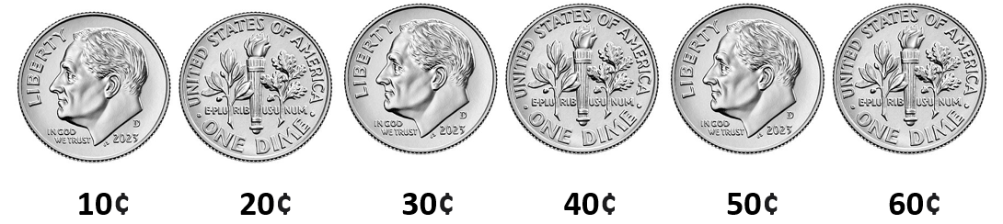

**Mathematical Representations:** As students develop their counting skills, they may be able to accurately count a small group of objects but struggle as the size of the group increases. Students may count objects more than once, skip objects altogether, or get lost in their counting. Students generally make these errors when counting too quickly or when they do not move and organize the objects when counting (see example below). Students who have difficulty counting larger quantities will need additional modeling of counting, starting with a smaller quantity and building up to a larger quantity, with an emphasis on moving the objects when counting them. The use of a 120 chart or a graphic organizer may be useful to help students organize objects as they are counting.

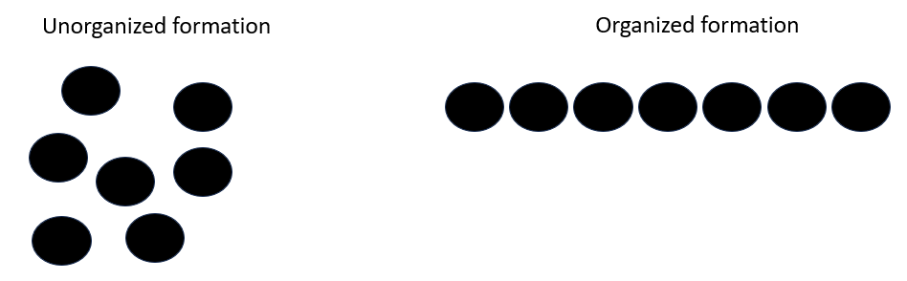

###### Concepts and Connections

Concepts

Flexibility with composing and decomposing base 10 numbers and understanding the structure to build relationships among numbers allows us to quantify, measure, and make decisions in life.

Connections

* *Within the grade level/course*:
  + 1.NS.2 – The student will represent, compare, and order quantities up to 120.
* *Vertical Progression*:
  + K.NS.1 – The student will utilize flexible counting strategies to determine and describe quantities up to 100.
  + 2.NS.1 – The student will utilize flexible counting strategies to determine and describe quantities up to 200.

Across Content Areas [Theme – Numbers, Number Sense, and Patterns]

* *Science:*
  + 1.6a,b – The student will use observations of the sun to describe patterns that can be predicted
  + 1.6b – The student will observe where the sun rises in the morning and sets in the evening and describe the pattern
* *Computer Science*:
  + 1.AP.1 – The student will apply computational thinking by sorting items into categories based on multiple attributes and create patterns.
    - a) Describe attributes of a set of objects.
    - b) List the attributes a set of objects have in common
    - c) Sort and classify concrete objects based on multiple attributes.
    - d) Create repeating and increasing patterns.
  + 1.DA.2 – The student will create representations of data to make predictions and draw conclusions.
    - c) Identify patterns and describe trends in data visualizations of various formats.
    - d) Use data to answer questions, draw conclusions, and make predictions.

###### Resources to Support Local Curriculum

* A list of approved textbooks and instructional materials is posted on the VDOE [website](https://www.doe.virginia.gov/teaching-learning-assessment/k-12-standards-instruction/mathematics/2024-mathematics-textbooks).

### 1.NS.2

##### The student will represent, compare, and order quantities up to 120.

1. Students will demonstrate the following Knowledge and Skills:
2. Read and write numerals 0-120 in sequence and out of sequence.
3. Estimate the number of objects (up to 120) in a given collection and justify the reasonableness of an answer.
4. Create a concrete or pictorial representation of a number using tens and ones and write the corresponding numeral up to 120 (e.g., 47 can be represented as 47 ones or it can be grouped into 4 tens with 7 ones left over).
5. Describe the number of groups of tens and ones when given a two-digit number and justify reasoning.
6. Compare two numbers between 0 and 120 represented pictorially or with concrete objects using the terms *greater than*, *less than*, or *equal to*.
7. Order three sets, each set containing up to 120 objects, from least to greatest, and greatest to least

###### Understanding the Standard

* Place value understanding is essential when representing, comparing, and ordering numbers. Hands-on experiences are essential to developing the ten-to-one place value understanding for the base 10 number system and to understanding the value of each digit in a two-digit number.
* Manipulatives that clearly illustrate the relationships among tens and ones as physically proportional are most appropriate for this grade (e.g., the tens piece is 10 times larger than the ones piece). Connecting cubes that students use to build rods of 10 serve as a valuable tool in the development of base 10 (ten-to-one) understanding. Ten-to-one trading activities with manipulatives on place value mats and base 10 blocks are more appropriate for students in Grade 2.
* Recording the numeral when using physical and pictorial models leads to an understanding that the position of each digit in a numeral determines the quantity it represents.
* Exploring ways to estimate the number of objects in a set, based on appearance (e.g., clustering, grouping, comparing), enhances the development of number sense.
* To estimate means to determine a number that is close to the exact amount without counting each individual object. When asking for a reasonable estimate of a number of objects in a set, teachers might ask, “*About* how much?” or “*About* how many?” or “Is this *about* 10, 50, or 100?”
* Opportunities to estimate a quantity, given a benchmark of 10 and/or 100 objects, enhance a student’s ability to estimate with greater accuracy. Examples could include Estimation Jars or Estimation Routines.
* When creating concrete or pictorial representations of a number up to 120, manipulatives such as connecting cubes, ten frames, cups and beans, and bundles of straws can be used to represent tens and ones, and to name and write the number.
* After naming and creating models of two-digit numbers, students can use the representation to describe a number in terms of tens and ones and justify reasoning.
* Students are generally familiar with the concept of *more* but have less experience with the concept of *less/fewer*. It is important to use the terms together to build an understanding of their relationship. For example, when asking which group has more, follow by asking which group has fewer. Symbols for comparing numbers (< and >) are not introduced until Grade 2.
* Opportunities to order sets (each set containing up to 120 objects) from least to greatest and greatest to least can be concrete (e.g., collections of money, connecting cubes, cups and beans) or pictorial (e.g., ten frames, math racks).

###### Skills in Practice

While the five process goals are expected to be embedded in each standard, the Skills in Practice highlight the most prevalent process goals in relation to the content presented.

**Mathematical Representations:** When writing the numerals for numbers up to 120, several mistakes may be evident in students’ work. Students may reverse the digits in the number (e.g., writing 14 for 41 or writing 29 for 92). Students may be unable to accurately write numbers over 100 (e.g., writing 1004 for 104). Students need additional opportunities to connect the base-10 concepts with oral and written number names. It is helpful to use groupable base-10 models when teaching number names and helping students make connections to the written numeral. See example below.

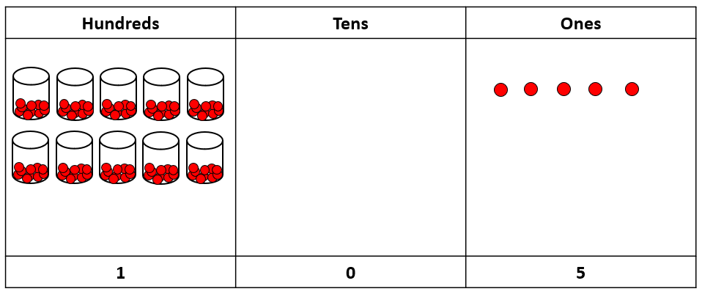

**Mathematical Communication:** Students’ lack of experience with the vocabulary associated with comparing numbers may contribute to a lack of understanding comparing numbers. For example, students may be familiar with the term “more” but have less experience with the terms “greater” and “less.” Students who struggle to use the terms accurately would benefit from experiences that use the terms together and connect them to quantities, first with concrete objects, then building to numerals. The use of number paths and/or hundreds charts are helpful in comparing numbers in relation to one another.

###### Concepts and Connections

Concepts

Flexibility with composing and decomposing base 10 numbers and understanding the structure to build relationships among numbers allows us to quantify, measure, and make decisions in life.

Connections

* *Within the grade level/course*:
  + 1.NS.1 – The student will utilize flexible counting strategies to determine and describe quantities up to 120.
* *Vertical Progression*:
  + K.NS.2 – The student will identify, represent, and compare quantities up to 30.
  + 2.NS.2 - The student will demonstrate an understanding of the ten-to-one relationships of the base 10 number system to represent, compare, and order whole numbers up to 999.

Across Content Areas

Reference 1.NS.1.

###### Resources to Support Local Curriculum

* A list of approved textbooks and instructional materials is posted on the VDOE [website](https://www.doe.virginia.gov/teaching-learning-assessment/k-12-standards-instruction/mathematics/2024-mathematics-textbooks).
* Counting and Writing Beyond 100 Exemplar Mathematics Instructional Plan ([Word](https://www.doe.virginia.gov/home/showpublisheddocument/51713/638398744720870000) | [PDF](https://www.doe.virginia.gov/home/showpublisheddocument/51715/638398744726670000))
* Comparing Numbers with Cubes and 10 Frames Exemplar MIP ([Word](https://www.doe.virginia.gov/home/showpublisheddocument/51725/638398744755270000) | [PDF](https://www.doe.virginia.gov/home/showpublisheddocument/51727/638398744761370000))
* Is it More or Less? Exemplar MIP ([Word](https://www.doe.virginia.gov/home/showpublisheddocument/51721/638398744743700000) | [PDF](https://www.doe.virginia.gov/home/showpublisheddocument/51723/638398744749330000))
* Estimate the Number of Objects to 120 Exemplar MIP ([Word](https://www.doe.virginia.gov/home/showpublisheddocument/51717/638398744731670000) | [PDF](https://www.doe.virginia.gov/home/showpublisheddocument/51719/638398744737600000))

### 1.NS.3

##### The student will use mathematical reasoning and justification to solve contextual problems that involve partitioning models into two and four equal-sized parts.

1. Students will demonstrate the following Knowledge and Skills:
2. Represent equal shares of a whole with two or four sharers, when given a contextual problem.
3. Represent and name halves and fourths of a whole, using a region/area model (e.g., pie pieces, pattern blocks, paper folding, drawings) and a set model (e.g., eggs, marbles, counters) limited to two or four items.
4. Describe and justify how shares are equal pieces or equal parts of the whole (limited to halves, fourths) when given a contextual problem.

###### Understanding the Standard

* Practical situations with fractions should involve real-life problems in which students themselves determine how to subdivide a whole into equal parts, test those parts to be sure they are equal, and use those parts to re-create the whole.
* When working with fractions, the whole must be defined.
* Fractions can have different meanings: part-whole, division, measurement, ratio, and operator. The focus in Grade 1 is to develop the idea of equal sharing (division) and part-whole relationships. Fraction notation will be introduced in Grade 2.
* An equal sharing problem is an idea that young children understand intuitively because of their experiences sharing objects with siblings, friends, etc. Consider the following examples:
  + two children sharing four sandwiches
  + two children sharing one sandwich
  + four children sharing one piece of paper
  + four children sharing two brownies (see image below)

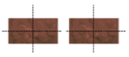or graphic of two brownies each divided into two parts or two brownies divided into four equal parts each

* In a region/area model, the whole is a continuous region and can be partitioned/divided into parts having the same area. Region/area models (e.g., circular and rectangular pie pieces, pattern blocks, geoboards, folding paper) are helpful tools for students. As they touch and move the concrete objects, students begin to understand the part-to-whole relationship and other concepts about fractions.
* In a set model, the whole is discontinuous. The set of discrete items represents the whole and each item in the set represents an equivalent part of the set. For example, in a set of four counters, one counter represents one-fourth of the set. In the set model, the set can be subdivided into subsets with the same number of items in each subset. For example, a set of four counters can be subdivided into two subsets of two counters each, with each subset representing one-half of the whole set.
* In the primary grades, having experiences with sets that are composed of congruent figures (e.g., eggs in a carton) before working with sets that have noncongruent parts (e.g., toy cars, models of dinosaurs) may help build understanding.
* Using formal fraction notation is not expected at this level. Connecting the vocabulary for halves and fourths to concrete models and contextual problems through informal, integrated experiences with fractions will help students develop a foundation for deeper learning in later grades.
* Providing opportunities to make connections and comparisons among fraction representations by connecting concrete or pictorial representations with spoken representations (e.g., “one-half,” “one part out of two equal parts,” or “one-half is more than one-fourth of the same whole”) deepens understanding of the language and meaning of fractions.

###### Skills in Practice

While the five process goals are expected to be embedded in each standard, the Skills in Practice highlight the most prevalent process goals in relation to the content presented.

**Mathematical Problem Solving:** As students engage in problem solving that require the use of halves and fourths in a contextual problem, students may demonstrate difficulty understanding what the problem is asking, or they may inaccurately solve the problem. Consider the examples below –

* Two friends share 4 cookies. Draw a picture to show fair shares.
  + Students may demonstrate multiple ways to solve this problem. Students may use their knowledge of doubles and are able to solve the task easily. Other students may share the cookies one by one until all are shared. It is important to focus on the idea of equality and to ask students how they know that the cookies have been shared fairly.
* Four friends share 2 brownies. Draw a picture to show how much each friend gets.
  + This problem presents the ideas of splitting a whole into equal parts and distributing the parts fairly. A common misconception is that since there are only two brownies, there is not enough to share with four friends. This response indicates that students have not developed an understanding of parts and wholes and may lack experiences in decomposing shapes.

**Mathematical Representations:** As students are developing their understanding of fraction concepts, a common student error is to create parts that are not equivalent. For example, students who respond to the prompt, *“Four friends share a pizza. How much of the pizza does each friend get?”* may partition the circle as seen below. This indicates that students do not understand the concept of “fair shares” or “equal parts.” These students would benefit from additional opportunities to divide area models (both circles and rectangles) for four sharers.

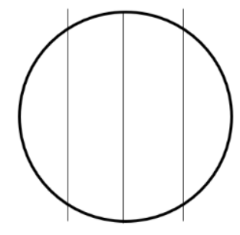

**Mathematical Communication:** Many students at this level are not proficient at using the formal vocabulary associated with fraction concepts (halves, fourths). For example, after splitting a cookie equally into two halves for themselves and their friend, they may state that each person gets “one piece” instead of stating that each person gets “one-half of the whole cookie.” Students who are unable to use fraction vocabulary accurately will need additional opportunities to see this vocabulary modeled by the teacher and to practice describing parts this way. See the example below.

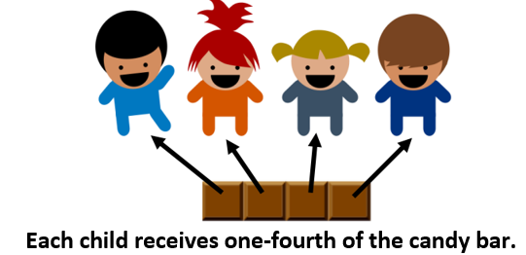

###### Concepts and Connections

Concepts

Flexibility with composing and decomposing base 10 numbers and understanding the structure to build relationships among numbers allows us to quantify, measure and make decisions in life.

Connections

* *Within the grade level/course*:
  + 1.MG.1 – The student will reason mathematically using nonstandard units to measure and compare objects by length, weight, and volume.
  + 1.MG.3 – The student will demonstrate an understanding of the concept of passage of time (to the nearest hour and half-hour) and the calendar.
* *Vertical Progression*:
  + There is no prior SOL connection as this is students’ first formal exposure to fractions.
  + 2.NS.3 – The student will use mathematical reasoning and justification to solve contextual problems that involve partitioning models into equal-sized parts (halves, fourths, eighths, thirds, and sixths).

Across Content Areas

Reference 1.NS.1.

###### Resources to Support Local Curriculum

* A list of approved textbooks and instructional materials is posted on the VDOE [website](https://www.doe.virginia.gov/teaching-learning-assessment/k-12-standards-instruction/mathematics/2024-mathematics-textbooks).

## Computation and Estimation

In K-12 mathematics, computation and estimation are integral to developing mathematical proficiency. Computation refers to the process of performing numerical operations, such as addition, subtraction, multiplication, and division. It involves applying strategies and algorithms to solve arithmetic problems accurately and efficiently. Estimation is the process of obtaining a reasonable or close approximation of a result without performing an exact calculation. Estimation is particularly useful when an exact answer is not required, especially in real-world situations, and when assessing the reasonableness of an answer. Computation and estimation are used to support problem solving, critical thinking, and mathematical reasoning by providing students with a range of approaches to solve mathematics problems quickly and accurately.

In Grade 1, students will use the operations of addition and subtraction to represent and solve many different types of problems. Students at this grade level will recall with automaticity addition and subtraction facts within 10; and will represent, solve, and justify solutions to single-step problems, including those in context, using addition and subtraction with whole numbers within 20. For building automaticity, the intentional use of timed exercises, such as flashcards and/or supplemental handouts aligned to the rigor of the standard that require students to generate many correct responses in a short amount of time are highly encouraged.

It is critical at this grade level that students build their conceptual understanding through concrete and pictorial representations in order to learn their basic facts as specified within the parameters of each standard of this strand. At this grade level, students begin to become efficient with problem solving strategies. Fluent use of standard algorithms will not only depend on automatic retrieval (automaticity) but will also reinforce them. Practice provides the foundation allowing students the ability to achieve mathematically accurate and systematic use of basic skills at a reasonably quick pace – freeing up working memory to solve complex problems in later grades. Automaticity further grounds students’ entry points and the structures needed to solve contextual problems and execute mathematical procedures.

### 1.CE.1

##### The student will recall with automaticity addition and subtraction facts within 10 and represent, solve, and justify solutions to single step problems, including those in context, using addition and subtraction with whole numbers within 20.

1. Students will demonstrate the following Knowledge and Skills:
2. Recognize and describe with fluency part-part-whole relationships for numbers up to 10 in a variety of configurations.
3. Demonstrate fluency with addition and subtraction within 10 by applying reasoning strategies (e.g., count on/count back, one more/one less, doubles, make ten).
4. Recall with automaticity addition and subtraction facts within 10.
5. Investigate, recognize, and describe part-part-whole relationships for numbers up to 20 in a variety of configurations (e.g., beaded racks, double ten frames).
6. Solve addition and subtraction problems within 20 using various strategies (e.g., inverse relationships: if 9 + 3 = 12 then 12 - 3 = 9; decomposition using known sums/differences: 9 + 7 can be thought of as 9 decomposed into 2 and 7, then use doubles, 7 + 7 = 14; 14 + 2 = 16 or decompose the 7 into 1 and 6; make a ten: 1 + 9 = 10; 10 + 6 = 16).
7. Represent, solve, and justify solutions to single-step addition and subtraction problems (join, separate, and part-part-whole) within 20, including those in context, using words, objects, drawings, or numbers.
8. Determine the unknown whole number that will result in a sum or difference of 10 or 20   
   (e.g., 14 - __ = 10 or 15 + __ = 20).
9. Identify and use (+) as a symbol for addition and (-) as a symbol for subtraction.
10. Describe the equal symbol (=) as a balance representing an equivalent relationship between expressions on either side of the equal symbol (e.g., 6 and 1 is the same as 4 and 3; 6 + 1 is balanced with 4 + 3; 6 + 1 = 4 + 3).
11. Use concrete materials to model, identify, and justify when two expressions are not equal (e.g., 10 - 3 is not equal to 3 + 5).
12. Use concrete materials to model an equation that represents the relationship of two expressions of equal value.
13. Write an equation that could be used to represent the solution to an oral, written, or picture problem.

###### Understanding the Standard

* Computational fluency is the ability to think flexibly to choose appropriate strategies to solve problems accurately and efficiently. Students should develop fluency and recall with automaticity facts to 10 and then use strategies and known facts to 10 to determine facts to 20.
* Flexibility requires knowledge of more than one approach to solving a particular kind of problem. Being flexible allows students to choose an appropriate strategy for the numbers involved, particularly where they do not need to recall with automaticity.
* Meaningful practice of computation strategies can be attained through hands-on activities, manipulatives, and graphic organizers.
* Accuracy is the ability to determine a correct answer using knowledge of number facts and other important number relationships.
* Efficiency is the ability to carry out a strategy effortlessly at a reasonably quick pace.
* Mathematically fluent students are not only able to provide correct answers quickly, but they are also able to use known facts and computation strategies to efficiently determine answers that they do not know.
* Automaticity of facts can be achieved through timed exercises such as flashcards and/or supplemental handouts to generate many correct responses in a short amount of time.
* Students should have the opportunity to subitize a set of objects presented in various configurations (e.g., regular and irregular dot patterns, five-frames, ten-frames, random arrangements). Subitizing is the ability to look at a small set of objects and instantly know how many there are without counting them. Generally, students at this level can subitize numbers up to 5 (and may be able to subitize larger numbers that are presented in an organized arrangement, such as a ten-frame). Subitizing is an important pre-requisite to developing computational fluency.
* Dot patterns should be presented in both regular and irregular arrangements. This will help students to understand that numbers are made up of parts and will later assist them in combining parts as well as counting on.

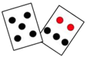

* Parts of numbers to 10 should be represented in different ways, such as five-frames, ten-frames, strings of beads, arrangements of tiles or toothpicks, dot cards, or beaded number frames.

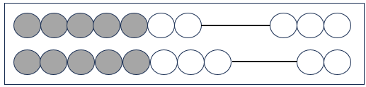

* Missing number cards (number bonds) help students see that numbers can be "broken" into pieces to make computation easier (decomposing/composing). With missing number cards, students recognize the relationships between numbers through a written model that shows how the numbers are related. A missing number card helps students clearly visualize the part-whole relationship.

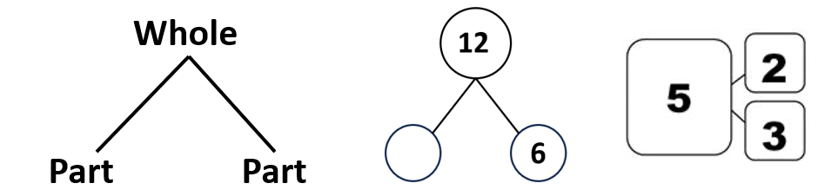

* Composing and decomposing numbers flexibly forms a basis for understanding properties of the operations and later formal algebraic concepts and procedures.
* Addition and subtraction are inverse operations and should be taught concurrently to develop an understanding of this relationship.
* Manipulatives should be used to develop an understanding of addition and subtraction facts.
* Students should have opportunities to select and use a variety of efficient strategies. Examples of strategies for developing basic addition and subtraction facts include:

**Examples of Addition and Subtraction Strategies**

|  |  |
| --- | --- |
| **Strategy** | **Example** |
| count all | 1, 2, 3, 4, 5, 6, 7 … |
| count on | 8, 9, 10, 11 … |
| count back | 12, 11, 10, 9 … |
| skip count | 5, 10, 15, 20… |
| one more than, two more than | one more than 5 is 6; two more than 8 is 10 |
| one less than, two less than | one less than 10 is 9; two less than 8 is 6 |
| doubles | 2 + 2 = 4; 3 + 3 = 6 |
| near doubles | 3 + 4 is the same as (3 + 3) + 1 |
| make 10 facts | 7 + 4 can be thought of as 7 + 3 + 1 (making a ten and one more) |
| think addition for subtraction | 9 – 5 can be thought of as “5 and what number makes 9?” |
| use of the commutative property | 4 + 3 is the same as 3 + 4 |
| use of the inverse property (related facts) | 4 + 3 = 7, 3 + 4 = 7, 7 – 4 = 3, and 7 – 3 = 4 |
| use of the additive identity property | 4 + 0 = 4, 0 + 4 = 4 |
| use patterns to make sums | 0 + 5 = 5, 1 + 4 = 5, 2 + 3 = 5 |

*Note: Students at this level are not expected to name the properties.*

* Flexibility with facts to 10 should be applied to facts to 20 (e.g., when adding 4 + 7, it is appropriate to think of 4 as 3 + 1 to combine 3 and 7 to make a 10, whereas when adding 4 + 8, it is appropriate to think of 4 as 2 + 2 to combine 8 and 2 to make a 10).
* The problem-solving process is enhanced when students:
  + visualize the action in the story problem and draw a picture to show their thinking;
  + model the problem using manipulatives, representations, and/or number sentences/equations; and
  + justify their reasoning and varied approaches through collaborative discussions.
* In problem-solving, emphasis should be placed on thinking and reasoning rather than on key words. Focusing on key words such as *in all, altogether, difference,* etc.,encourages students to perform a particular operation rather than make sense of the context of the problem. A key word focus prepares students to solve a limited set of problems and often leads to incorrect solutions as well as challenges in upcoming grades and courses.
* Extensive research has been undertaken over the last several decades regarding different problem types. Many of these studies have been published in professional mathematics education publications using different labels and terminology to describe the varied problem types.

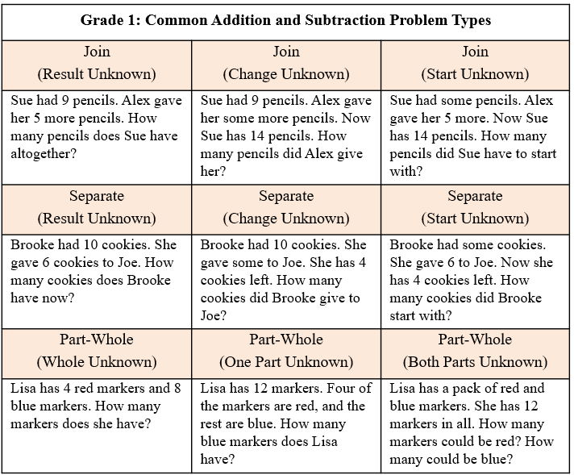

* A variety of problem types related to addition and subtraction are represented in the chart above. Another problem type, Compare Problems, will be introduced to students in Grade 2. At this level, Join Problems (with start unknown) and Separate Problems (with start unknown) are the most challenging for students.
* Equations should be routinely modeled in conjunction with story problems. Manipulatives such as connecting cubes and counters can be used to model equations.
* Equality can be shown using a balance scale or a number balance. An equation, such as 3 + 5 = 6 + 2, can be represented using a balance scale, with equal amounts on each side.
* An equation (number sentence) is a mathematical statement representing two expressions that are equivalent. It consists of two expressions, one on each side of an equal symbol (e.g., 5 + 3 = 8, 8 = 5 + 3 and 4 + 3 = 9 − 2).
* An expression is a representation of a quantity. It contains numbers, variables, and/or computational operation symbols. It does not have an equal symbol (e.g., 5, 4 + 3, 8 − 2). Students at this level are not expected to use the term expression.
* At this level, equality should be represented using objects, pictures, words, and symbols (the equal symbol), while inequality should be communicated primarily through words such as not equal, not equivalent, not the same, etc. Students will be formally introduced to the “not equal” symbol (≠) in Grade 2.
* A common misunderstanding is that the equal symbol always means “the answer comes next.” The equal symbol represents a balance between expressions. The equal symbol means “is the same as” or “another name for” or “equal in value.” Exploring equations in less familiar forms can help students build understanding of the equal symbol (e.g., 8 = 10 - 2, 5 = 5, or 7 = 12 - 5).
* Experiences looking at equations and determining whether they are true or not true (e.g., 5 = 9 – 4 is true and 6 + 5 = 15 – 2 is not true) will help develop an understanding of equality and inequality.
* Inequalities such as 5 < 4 + 3 are not equations. Equations must have an equal symbol (e.g., 5 + 6 = 11). Students at this level are not expected to work with inequalities.
* Solving missing addend contextual problems supports the understanding of equality and the use of the equal symbol (e.g., There are four birds in the tree. Some more birds fly to the tree. Now there are six birds in the tree. How many birds flew to the tree? 4 +__ = 6).

###### Skills in Practice

While the five process goals are expected to be embedded in each standard, the Skills in Practice highlight the most prevalent process goals in relation to the content presented.

**Mathematical Problem Solving:**

* As students are exposed to different problem types (see table of problem types in Understanding the Standard), they may have difficulty determining which operation to use to solve the problem. A common student error is to pull the numbers out of the contextual situation and add them. Instead, students need to make sense of the problem by first determining the action taking place. Opportunities to physically act out problems or to model problems with concrete objects to visualize the action occurring in the problem will help students make sense of problems.
* Automatic retrieval of facts (automaticity) allows students more mental energy to devote to relatively complex mathematical tasks and execute multistep mathematical procedures. Thus, building automatic fact retrieval in students is one (of many) important goal when engaging in problem solving.
  + Ensure that students have an efficient strategy to use when solving basic facts. When teaching basic facts, instruction should be organized related to number combinations (see Examples of Addition and Subtraction Strategies table in Understanding the Standards). For example, when solving single-step addition and subtraction problems within 20, students should use flexible counting strategies and/or models (e.g., number bonds, ten frames) to develop their automaticity while also developing their understanding of composition and decomposition of numbers. Students should demonstrate their understanding using words, objects, drawings, and numbers. For example, when given 6 + ___ = 10 (or the related fact of 10 – 6 = ___), students can create a concrete model or pictorial representation. A number bond (see below) is one strategy that can be used to support students’ learning of math facts to build both automaticity and procedural fluency.

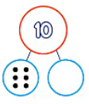

* + Timed activities should be added once students have been working on developing accuracy and flexibility with such facts over many lessons. Choose the activity and materials to use in the timed activity while setting clear expectations. Timed activities can be structured for students to work together as a group or individually. If using worksheets for fluency, discuss students’ answers after time has been called and ask students to correct and explain any missed items. For group timed activities, students work in pairs or small groups, taking turns to respond or responding at once. For group activities or flash cards with a teacher, teachers should provide immediate feedback. If students are incorrect, teachers should allow students to self-correct and help them do so if necessary. Having students chart their individual progress over time can build motivation to set goals and encourage students to stay focused on achieving fluency and automaticity.

**Mathematical Communication:** Teach students a solution method for solving each problem type. Introduce a solution method using a worked-out example. Talk through the problem-solving process and connect the relevant problem information to the worked-out example. Say out loud the decisions that were made to solve the problem at each step. Then demonstrate how to apply the solution method by solving a similar problem with students using that method. Discuss each decision made and ask students guiding questions to engage them as problems are solved.

**Mathematical Reasoning:**

* Students should apply a variety of reasoning strategies as they build the accuracy and flexibility components of fluency with addition and subtraction within 10 (e.g., counting on, use of number lines, doubles). Students should have opportunities to solve problems and share their thinking with peers, allowing students to hear a variety of strategies. This may include an introduction to more efficient strategies, which will enhance students’ abilities to flexibly compose/decompose numbers to 10.
* Basic fact strategies use number relationships and benchmarks and support students, merging conceptual understanding and procedural fluency. Strategies build a foundation for strategies beyond basic facts. For example –

**5 + 4 = _____**

When looking at this problem, students need to add or combine the 4 and the 5. Teachers may use counters to count out a group of 4 and another group of 5, combine them, and count how many counters are there in all. To transfer from the concrete, draw 4 squares to represent the 4 and 5 squares for the 5, and then count how many squares are drawn in all (the result is 9 squares), so the answer to the problem 4 + 5 equals 9.

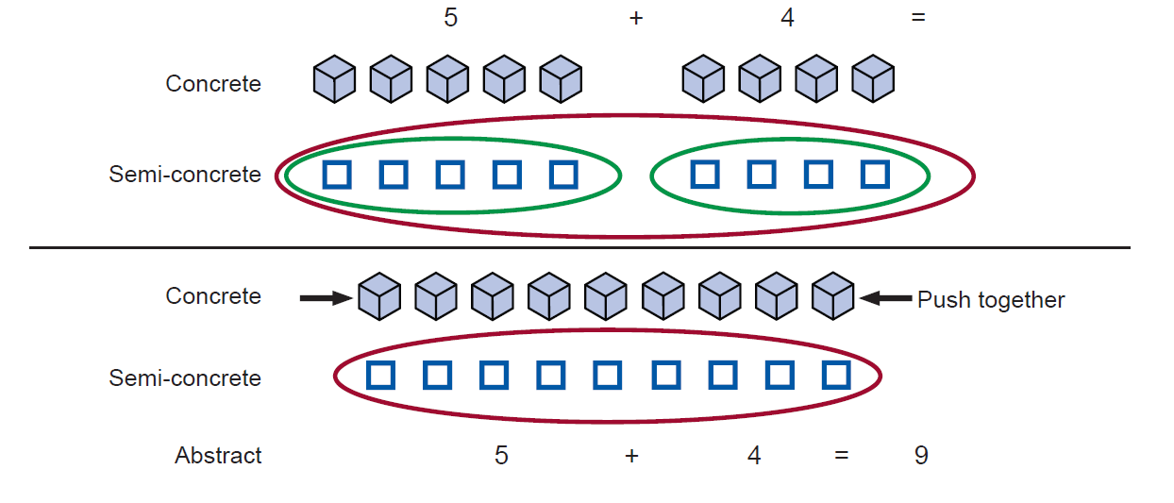

**Mathematical Connections:** Students are often more comfortable with addition than subtraction. With practice composing, decomposing, modeling, looking at relationships among fact families, and having students provide verbal explanations, students can better understand how addition and subtraction are related, helping to develop their accuracy and flexibility components of computational fluency.

**Mathematical Representations:** At this level, students are formally introduced to the addition and subtraction symbols (+ and -). Some students may have difficulty using the symbols correctly. Symbols only have meaning for students when they are associated with the reality they represent. The number combinations and relationships that students need to understand can best be learned through experiences that include counting, comparing, composing, and decomposing groups of objects. Consistency in the types of representations shared in core classroom instruction and during intervention sessions, throughout the year and across grades, is critical. Consistent use is particularly important for students who are struggling to grasp a concept or operation. Using a core set of representations across settings and grades helps reinforce instruction on the same concepts and develops students’ automaticity.

###### Concepts and Connections

Concepts

The operations of addition and subtraction are used to represent and solve many different types of problems.

Connections

* *Within the grade level/course*:
  + 1.PS.1g) Analyze data represented in object graphs, picture graphs, and tables and communicate results:
    - i) ask and answer questions about the data represented in object graphs, picture graphs, and tables (e.g., total number of data points represented, how many in each category, how many more or less are in one category than another)
* *Vertical Progression*:
  + K.CE.1 – The student will model and solve single-step contextual problems using addition and subtraction with whole numbers within 10.
  + 2.CE.1 – The student will recall with automaticity addition and subtraction facts within 20 and estimate, represent, solve, and justify solutions to single-step and multistep problems, including those in context, using addition and subtraction with whole numbers where addends or minuends do not exceed 100.

###### Resources to Support Local Curriculum

* A list of approved textbooks and instructional materials is posted on the VDOE [website](https://www.doe.virginia.gov/teaching-learning-assessment/k-12-standards-instruction/mathematics/2024-mathematics-textbooks).

## Measurement and Geometry

In K-12 mathematics, measurement and geometry allow students to gain understanding of the attributes of shapes as well as develop an understanding of standard units of measurement. Measurement and geometry are imperative as students develop a spatial understanding of the world around them. The standards in the measurement and geometry strand aim to develop students’ special reasoning, visualization, and ability to apply geometric and measurement concepts in real-world situations.

In Grade 1, students analyze and describe geometric objects, the relationships and structures among them, and the space they occupy as students classify, quantify, measure, or count one or more attributes. At this grade level, students will use nonstandard units to measure and compare objects by length, weight, and volume; describe, sort, draw, and name plane figures (circles, triangles, squares, and rectangles); compose larger plane figures by combining simple plane figures; and demonstrate an understanding of the concept of passage of time (to the nearest hour and half-hour) and the calendar.

### 1.MG.1

##### The student will reason mathematically using nonstandard units to measure and compare objects by length, weight, and volume.

1. Students will demonstrate the following Knowledge and Skills:
2. Use nonstandard units to measure the:
   1. lengths of two objects (units laid end to end with no gaps or overlaps) and compare the measurements using the terms *longer/shorter*, *taller/shorter*, or *the same as*;
   2. weights of two objects (using a balance scale or a pan scale) and compare the measurements using the terms *lighter, heavier*, or *the same as*; and
   3. volumes of two containers and compare the measurements using the terms *more*, *less*, or *the same as*.
3. Measure the length, weight, or volume of the same object or container with two different units and describe how and why the measurements differ.

###### Understanding the Standard

* Measurement involves comparing an attribute of an object to the same attribute of the unit of measurement (e.g., the length of the edge of a cube measures the length of a book; the weight of the cube measures the weight of the book; the volume of the cube measures the volume of a container). Students need experiences that help develop their understanding that the length measurement of an object is the number of same-size nonstandard tools of length (e.g., connecting cubes, paper clips, erasers) with no gaps or overlaps.
* The process of measurement involves selecting a unit of measure, comparing the unit to the object to be measured, counting the number of times the unit is used to measure the object, and arriving at an approximate total number of units.
* Premature use of instruments or formulas leaves children without the understanding necessary for solving measurement problems.
* When children’s initial explorations of length, weight, and volume involve the use of nonstandard units, they develop some understanding of the need for standard measurement units for length, weight, and volume, especially when they communicate with others about these measures.
* Students develop conservation of measurement when they understand that the attributes do not change when the object is manipulated (e.g., a piece of string that is coiled maintains its length as it is straightened; the volume of water does not change when poured from a pitcher into a fish tank).
* Length is the distance between two points. Through hands-on experiences, students should develop an understanding that the length of an object is determined by laying same-size nonstandard units (e.g., connecting cubes, paper clips, erasers) end to end with no gaps or overlaps.
* Weight is a measure of the heaviness of an object. Experiences comparing the weights of two objects (one in each hand) using the terms “lighter,” “heavier,” or “the same” promote an understanding of the concept of balance.
* Physically measuring the weights of objects, using a balance scale, helps students develop an intuitive idea of what it means to say something is “lighter,” “heavier,” or “the same.”
* Balance scales are instruments used for comparing weight. A balance scale usually has a beam that is supported in the center. On each side of the beam are two identical trays. When the trays hold equal weights, the beam is level, and the scale is “balanced.” If the trays do not hold equal weights, the tray containing less weight will rise and the tray containing more weight will fall (see image below).

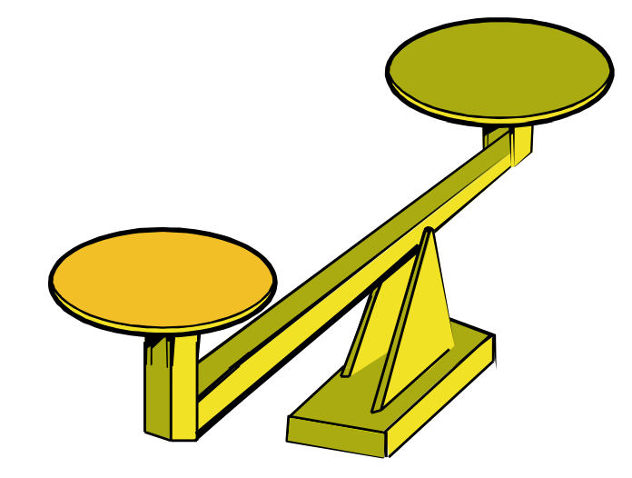

* Volume is the measure of the capacity of a container and how much it holds.
* Experiences that include pouring the contents of one container into another to compare the volumes of the two containers to determine whether the volume of one is more, less, or equivalent are needed.
* Varying and mixing the sizes and/or shapes of the containers (e.g., using short, wide containers as well as tall, narrow containers) provide opportunities for students to explore and develop an understanding of how volume changes.
* Opportunities to measure the same item using different units provide opportunities for students to develop an understanding of why using paperclips to determine the length of a desk results in a different measurement than using glue sticks to measure the length of the same desk. This is because paper clips are smaller than glue sticks and therefore it takes fewer glue sticks to measure the length of a desk than paper clips. Similarly, when measuring the volume of a bucket, using tennis balls instead of pom poms would lead to different measurements, as it would take more pom poms to fill the bucket than tennis balls.

###### Skills in Practice

While the five process goals are expected to be embedded in each standard, the Skills in Practice highlight the most prevalent process goals in relation to the content presented.

**Mathematical Problem Solving:** Students may struggle as they engage in measurement problem solving tasks using length, weight, and volume.

* *Length*: Some students may have difficulty iterating a unit along the length of the objects provided. They may leave gaps between subsequent units or overlap units (see the examples below). Opportunities to model how to appropriately measure are important. Students should have experience using various nonstandard units to measure objects. Inch color tiles and other manipulatives can provide a transition from nonstandard units to the use of a ruler in Grade 2.

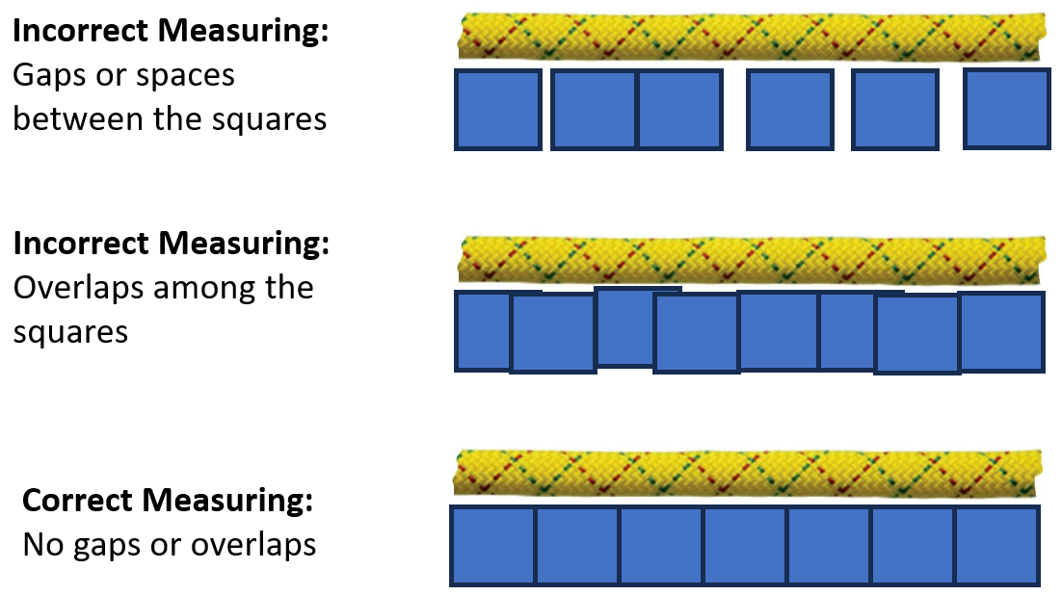

* *Weight*: Students may use two different nonstandard units to measure the weight of two different objects. This is evidence that the students do not understand that the same unit needs to be used when comparing weights. Students would also benefit from measuring the weight of the same object using a variety of nonstandard units of different weights. These experiences will reinforce the concept that a unit’s size matters and that the heavier the unit, the fewer the number of units needed to measure weight.
* *Volume*: Some students will struggle to compare the number of nonstandard units that two different containers can hold. These students may not be able to count the objects using one-to-one correspondence. Another common error for students at this level is thinking that tall and thin containers automatically hold more than a shorter and wider container. Activities that allow students to use many different containers of various shapes and sizes will support student understanding.

**Mathematical Communication:** Students should have many opportunities to measure the length, weight, and volume of various objects and containers. Students should be encouraged to share their strategies for measuring and hear the strategies of other students.

###### Concepts and Connections

Concepts

Analyzing and describing geometric objects in our world, the relationships and structures among them, or the space that they occupy can be used to classify, quantify, measure, or count one or more of their attributes.

Connections

* *Within the grade level/course*:
  + 1.PS.1 – The student will apply the data cycle (pose questions; collect or acquire data; organize and represent data; and analyze data and communicate results) with a focus on object graphs, picture graphs, and tables.
* *Vertical Progression*:
  + K.MG.1 – The student will reason mathematically by making direct comparisons between two objects or events using the attributes of length, height, weight, volume, and time.
  + 2.MG.1 – The student will reason mathematically using standard units (U.S. Customary) with appropriate tools to estimate, measure, and compare objects by length, weight, and liquid volume to the nearest whole unit.

Across Content Areas [Theme – Modeling]

* *Science:* In Grade 1, students are expected to use physical models to demonstrate simple phenomena and natural processes.
  + 1.4b – The student will create and interpret a physical model/drawing of a plant, including roots, stems, leaves, and flowers to identify and explain the functions of each plant part
  + 1.5a – The student will design and construct a model of a habitat for an animal based on physical characteristics.
* *Computer Science:* 
  + 1.DA.2 – The student will create representations of data to make predictions and draw conclusions.
    - a) Collect and organize data with or without a computing device.
    - b) Create tables, object graphs, picture graphs, and models using abstraction.

###### Resources to Support Local Curriculum

* A list of approved textbooks and instructional materials is posted on the VDOE [website](https://www.doe.virginia.gov/teaching-learning-assessment/k-12-standards-instruction/mathematics/2024-mathematics-textbooks).

### 1.MG.2

##### The student will describe, sort, draw, and name plane figures (circles, triangles, squares, and rectangles), and compose larger plane figures by combining simple plane figures.

1. Students will demonstrate the following Knowledge and Skills:
2. Describe triangles, squares, and rectangles using the terms sides, vertices, and angles. Describe a circle using terms such as *round* and *curved*.
3. Sort plane figures based on their characteristics (e.g., number of sides, vertices, angles, curved).
4. Draw and name the plane figure (circle, square, rectangle, triangle) when given information about the number of sides, vertices, and angles.
5. Identify, name, and describe representations of circles, squares, rectangles, and triangles, regardless of orientation, in different environments and explain reasoning.
6. Recognize and name the angles found in rectangles and squares as right angles.
7. Compose larger plane figures by combining two or three simple plane figures (triangles, squares, and/or rectangles).

###### Understanding the Standard

* An important part of the geometry strand in kindergarten through Grade 2 is the naming and describing of figures. Children move from their own vocabulary and begin to incorporate conventional terminology as the teacher uses geometric terms.
  + A plane figure is any closed, two-dimensional shape.
  + A vertex is the point at which two or more lines, line segments, or rays meet to form an angle. The term *vertices* is the plural form of vertex.

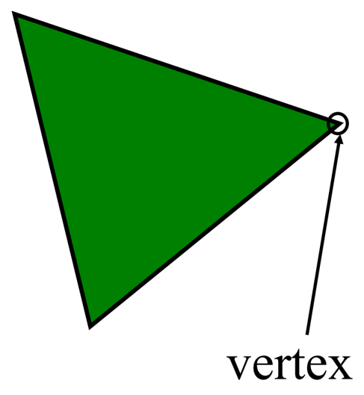

* + A line is a collection of points extending indefinitely in both directions. It has no endpoints.
  + A line segment is part of a line. It has two endpoints and includes all the points between and including those endpoints.
  + A ray is part of a line. It has one endpoint and extends indefinitely in one direction.
  + An angle is formed by two rays that share a common endpoint called the vertex. Angles are found wherever lines or line segments intersect.
  + A polygon is a closed plane figure composed of at least three line segments that do not cross.
  + Students at this level do not need to use the terms *line, line segment, ray,* or *polygon*.
  + A triangle is a polygon with three sides and three vertices.
  + A quadrilateral is a polygon with four sides. Students at this level do not need to use the term *quadrilateral*.
  + A rectangle is a quadrilateral with four right angles. A right angle measures exactly 90 degrees.
  + A square is a special rectangle with four sides of equal (congruent) length and four right angles. Students at this level do not need to use the term *congruent*.
  + A circle is the set of points in a plane that are the same distance from a point called the center. A circle is not a polygon, because it does not have straight sides.
* Triangles, rectangles, and squares should be presented in a variety of spatial orientations so that students do not develop the common misconception that triangles, rectangles, and squares must have one side parallel to the bottom of the page on which they are printed. See the examples below.

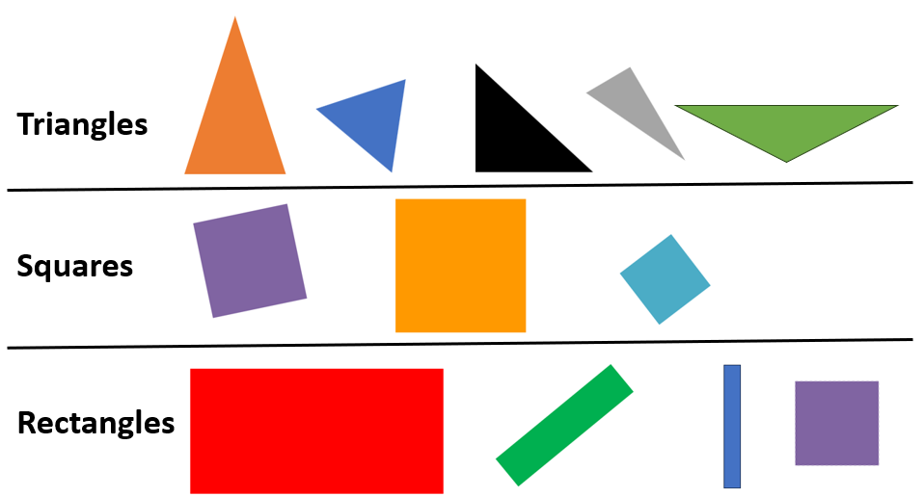

* Representations of circles, squares, rectangles, and triangles can be found in students’ environments at school and at home.
* A common misconception that students develop is referring to a rotated square as a diamond. Ongoing clarification should be provided (i.e., a square is a square regardless of its location in space; there is no plane figure called a diamond).
* Early experiences with comparing, sorting, composing, and subdividing figures or manipulatives (e.g., pattern blocks, attribute blocks) assist students in analyzing the characteristics of plane geometric figures.
* Polygons can be constructed using other polygons (e.g., two right triangles can be joined to create a square; two squares can be combined to create a rectangle; two trapezoids can be combined to create a hexagon). See the examples below. Students at this level do not need to know the terms *trapezoid* or *hexagon*.

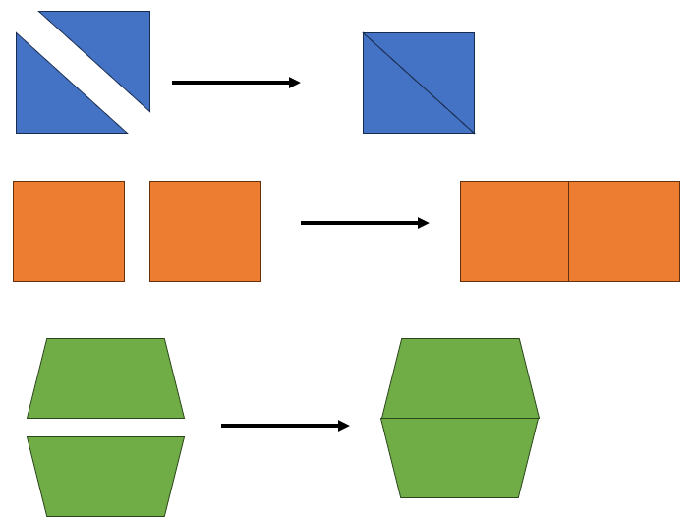

###### Skills in Practice

While the five process goals are expected to be embedded in each standard, the Skills in Practice highlight the most prevalent process goals in relation to the content presented.

**Mathematical Communication:** Students may have difficulty recalling the names of shapes that meet given characteristics, or they may not understand the terms that describe the shapes (e.g., sides, vertices, angles). These students will need additional opportunities to explore and name shapes and describe their characteristics. Word banks or vocabulary cards may be helpful as students become more comfortable with these terms. It is important to use these terms during instruction so that they become familiar to students. Activities such as sorting shapes using descriptors and characteristics or the use of graphic organizers that require students to group objects based on their characteristics will provide opportunities for students to accurately use geometry terms.

**Mathematical Connections:** Students should have opportunities to sort sets of shapes based on various attributes. Students should be encouraged to sort a set of shapes in multiple ways and explain how they sorted the shapes each time. This provides an important connection to students sorting and classifying concrete objects into appropriate subsets based on one or two attributes, and to describe and label attributes of a set of objects that has been sorted. The example below shows two ways (by color and by number of sides) to sort the following five shapes:

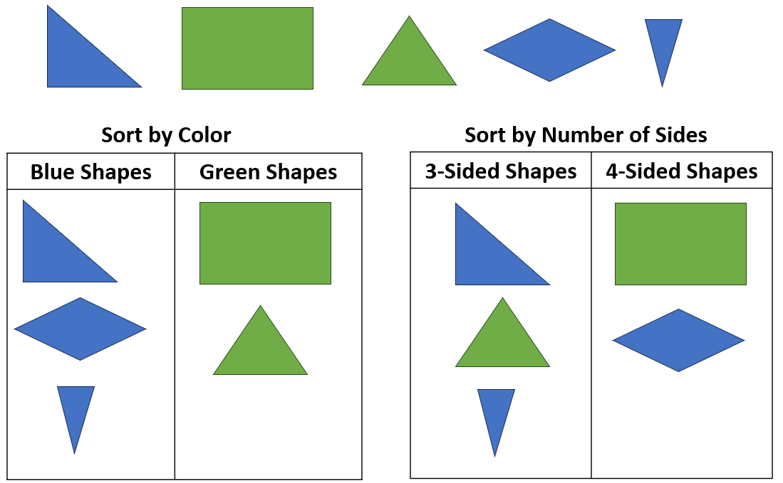

###### Concepts and Connections

Concepts

Analyzing and describing geometric objects in our world, the relationships and structures among them, or the space that they occupy can be used to classify, quantify, measure, or count one or more of their attributes.

Connections

* *Within the grade level/course*:
  + 1.PS.1a – Sort and classify concrete objects into appropriate subsets (categories) based on one or two attributes, such as size, shape, color, and/or thickness (e.g., sort a set of objects that are both red and thick).
  + 1.PS.1b – Describe and label attributes of a set of objects that has been sorted.
* *Vertical Progression*:
  + K.MG.2 – The student will identify, describe, name, compare, and construct plane figures (circles, triangles, squares, and rectangles).
  + 2.MG.3 – The student will identify, describe, and create plane figures (including circles, triangles, squares, and rectangles) that have at least one line of symmetry and explain its relationship with congruency.

Across Content Areas

Reference 1.MG.1.

###### Resources to Support Local Curriculum

* A list of approved textbooks and instructional materials is posted on the VDOE [website](https://www.doe.virginia.gov/teaching-learning-assessment/k-12-standards-instruction/mathematics/2024-mathematics-textbooks).

### 1.MG.3

##### The student will demonstrate an understanding of the concept of passage of time (to the nearest hour and half-hour) and the calendar.

1. Students will demonstrate the following Knowledge and Skills:
2. Identify different tools to measure time including clocks (analog and digital) and calendar.
3. Describe the units of time represented on a clock as minutes and hours.
4. Tell time to the hour and half-hour, using analog and digital clocks.
5. Describe the location of the hour hand relative to time to the hour and half-hour on an analog clock.
6. Describe the location of the minute hand relative to time to the hour and half-hour on an analog clock.
7. Match the time shown on a digital clock to an analog clock to the hour and half-hour.
8. Identify specific days/dates on a calendar (e.g., What date is Saturday? How many Fridays are in October?).
9. Use ordinal numbers first through tenth to describe the relative position of specific days/dates (e.g., What is the first Monday in October? What day of the week is May 6th?).
10. Determine the day/date before and after a given day/date (e.g., Today is the 8th, so yesterday was the ?), and a date that is a specific number of days/weeks in the past or future (e.g., Tim’s birthday is in 10 days, what will be the date of his birthday?).

###### Understanding the Standard

* Many experiences using clocks help students develop an understanding of the telling of time to the hour and half-hour, including:
  + identifying the parts of an analog clock (minute and hour hands);
  + demonstrating a given time to the hour and half-hour, using a model clock;
  + writing digital time to the hour and half-hour;
  + relating time on the hour and half-hour to daily routines and school schedules (e.g., bedtime, lunchtime, recess time); and
  + connecting the hour and half-hour to fraction concepts.
* The use of a one-handed demonstration clock can help students estimate the location of the missing hand and predict a possible time.
* Practical situations are appropriate to develop a sense of the interval of time between events (e.g., club meetings occur every week on Monday; there is one week between meetings).
* The calendar is a way to represent units of time (e.g., days, weeks, months, years).
* Using a calendar develops the concept of day as a 24-hour period rather than as a period of time from sunrise to sunset.
* The calendar provides an opportunity to discuss and use ordinal numbers to describe the sequence of events (e.g., today is April 4th; yesterday was April 3rd; tomorrow will be April 5th).
* An ordinal number is a number that names the place or position of an object in a sequence or set (e.g., first, second, third). *Ordered position*, *ordinal position*, and *ordinality* are terms that refer to the place or position of an object in a sequence or set. Practical applications of ordinal numbers can be experienced through calendar and patterning activities.
* At this level recognizing or reading the written words for ordinal numbers (e.g., first, second, third) is not expected.

###### Skills in Practice

While the five process goals are expected to be embedded in each standard, the Skills in Practice highlight the most prevalent process goals in relation to the content presented.

**Mathematical Communication:**

* *Clocks:* When determining the time using an analog clock, there are several common errors that students may make. For example, students may confuse the minute hand and the hour hand. Students may also struggle to read the clock when the minute hand is on the twelve, and may state the time as “twelve o’clock,” regardless of where the hour hand is located. Or they may read the clock incorrectly, such as stating the time as “twelve four” instead of 4:00. For students who are struggling to read an analog clock correctly, it may be beneficial to spend some time using only the hour hand and discussing things that happen at certain hours of the day and having students notice where the hour hand is pointing.

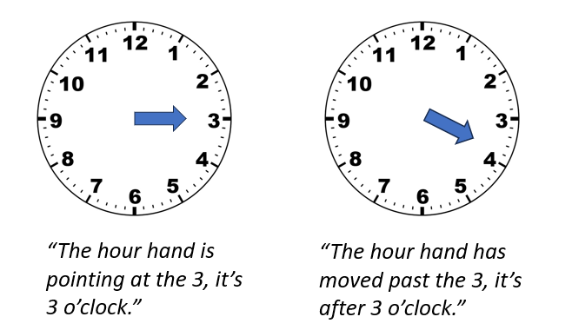

* *Calendars:* When working with calendars, students may confuse the day with the date. These students need additional practice to develop an understanding of this terminology. It would be beneficial to include these terms in daily calendar time and throughout the school day (e.g., *“We have music class every Wednesday, but the date of each Wednesday is different.”*).

**Mathematical Connections:** It is important that students have opportunities to make connections between analog and digital clocks by seeing the same time represented on both types of clocks. An expectation of this standard is to match the time on a digital clock to an analog clock to the hour and half-hour.

**Mathematical Representations:** While digital clocks are more common in students’ environments, some students may still struggle to read and write the time digitally. For example, some students will struggle to identify the beginning of the hour as “o’clock” and may need additional opportunities to practice telling time to the nearest hour and half-hour.

###### Concepts and Connections

Concepts

Analyzing and describing geometric objects in our world, the relationships and structures among them, or the space that they occupy can be used to classify, quantify, measure, or count one or more of their attributes.

Connections

* *Within the grade level/course*:
  + 1.NS.3 – The student will use mathematical reasoning and justification to solve contextual problems that involve partitioning models into two and four equal-sized parts.
* *Vertical Progression*:
  + There is no prior SOL connection as this is students’ first formal exposure to telling time using analog and digital clocks.
  + 2.MG.2 – The student will demonstrate an understanding of the concept of time to the nearest five minutes, using analog and digital clocks.

Across Content Areas

Reference 1.MG.1.

###### Resources to Support Local Curriculum

* A list of approved textbooks and instructional materials is posted on the VDOE [website](https://www.doe.virginia.gov/teaching-learning-assessment/k-12-standards-instruction/mathematics/2024-mathematics-textbooks).

## Probability and Statistics

In K-12 mathematics, probability and statistics introduce students to the concepts of uncertainty and data analysis. Probability involves understanding the likelihood of events occurring, often using concepts such as experiments, outcomes, and the use of fractions and percentages. The formal study or probability begins in Grade 4. Statistics focuses on collecting, organizing, and interpreting data and includes a basic understanding of graphs and charts. Probability and statistics help students analyze and make sense of real-world data and are fundamental for developing critical thinking skills and making informed decisions using data.

In Grade 1, students begin to understand that the world can be investigated through posing questions and collecting, representing, analyzing, and interpreting data to describe and predict events and real-world phenomena. At this grade level, students will apply the data cycle (pose questions; collect or acquire data; organize and represent data; and analyze data and communicate results) with a focus on object graphs, picture graphs, and tables.

### 1.PS.1

##### The student will apply the data cycle (pose questions; collect or acquire data; organize and represent data; and analyze data and communicate results) with a focus on object graphs, picture graphs, and tables.

1. Students will demonstrate the following Knowledge and Skills:
2. Sort and classify concrete objects into appropriate subsets (categories) based on one or two attributes, such as size, shape, color, and/or thickness (e.g., sort a set of objects that are both red and thick).
3. Describe and label attributes of a set of objects that has been sorted.
4. Pose questions, given a predetermined context, that require the collection of data (limited to 25 or fewer data points for no more than four categories).
5. Determine the data needed to answer a posed question and collect the data using various methods (e.g., counting objects, drawing pictures, tallying).
6. Organize and represent a data set by sorting the collected data using various methods (e.g., tallying, T-charts).
7. Represent a data set (vertically or horizontally) using object graphs, picture graphs, and tables.
8. Analyze data represented in object graphs, picture graphs, and tables and communicate results:
   1. ask and answer questions about the data represented in object graphs, picture graphs, and tables (e.g., total number of data points represented, how many in each category, how many more or less are in one category than another); and
   2. draw conclusions about the data and make predictions based on the data.

###### Understanding the Standard

* Students should explore the entire data cycle with a question and set of data that has been collected or acquired. Student reflection should occur throughout the data cycle. The data cycle includes the following steps: formulating questions to be explored with data, collecting or acquiring data, organizing and representing data, and analyzing and communicating results.

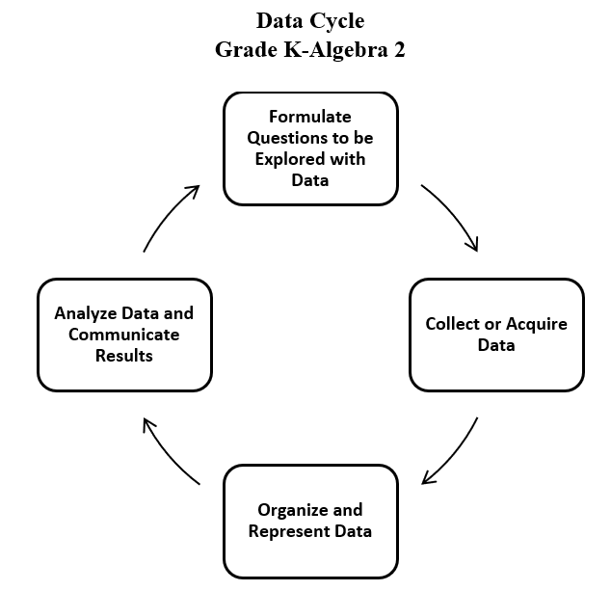

* Sorting, classifying, and ordering real and symbolic objects (e.g., manipulatives, buttons, shoes, animals) facilitates work with patterns, geometric shapes, and data (e.g., organizing the data to represent the data in a graph to support analysis).
* To sort is to compare a set of objects in order to find similarities and differences, so that they may be arranged into organized groups.
* To classify is to arrange or organize a set of objects according to a category or attribute (a quality or characteristic).
* The same set of objects can be sorted and classified in different ways. For example, a collection of non-perishable food items can be sorted and classified by container (boxes or cans) and by type (vegetable, meat, or pasta).
* A Venn diagram can be a helpful tool when sorting by more than one attribute.
* One way to explore attributes is to investigate non-examples (e.g., a circle could be a non-example in a sort of rectangles and triangles).
* General similarities and differences among items are easily observed by primary students, who can begin to focus on more than one attribute at a time. During the primary grades, the teacher’s task is to move students toward a more sophisticated understanding of classification in which two or more attributes connect or differentiate sets, such as those found in nature (e.g., leaves with different colors and different shapes).
* Data are pieces of information collected about people or things. The primary purpose of collecting data is to answer questions. The primary purpose of interpreting data is to inform decisions (e.g., which type of clothing to pack for a trip based on a weather graph or which type of lunch to serve based on class favorites).
* The teacher can provide data sets to students in addition to students engaging in their own data collection. Data may be acquired from resources that are already created (e.g., list of student birthdays, transportation lists, weather data, lunchroom data, media center data, data from a previously conducted experiment).
* After generating questions, students decide what information is needed and how it can be collected. At this level, students may need scaffolded support to formulate questions that can be answered with the collection of data.
* Data collection could involve voting, informal surveys, tallying, and charts (e.g., recording daily temperature, lunch count, attendance, favorite ice cream). Collection of data often leads to new questions to be investigated.
* Surveys, which are data collection tools that list choices, should provide a limited number of choices at the primary grades. For example, when surveying classmates about their favorite pet, answer choices should be limited to four or less options.
* Tallying is a method of gathering information. Tally marks are used to show how often something happens or occurs. Each tally mark represents one occurrence. Tally marks are clustered into groups of five, with four vertical marks representing the first four occurrences and the fifth mark crossing the first four on a diagonal to represent the fifth occurrence (see example below).

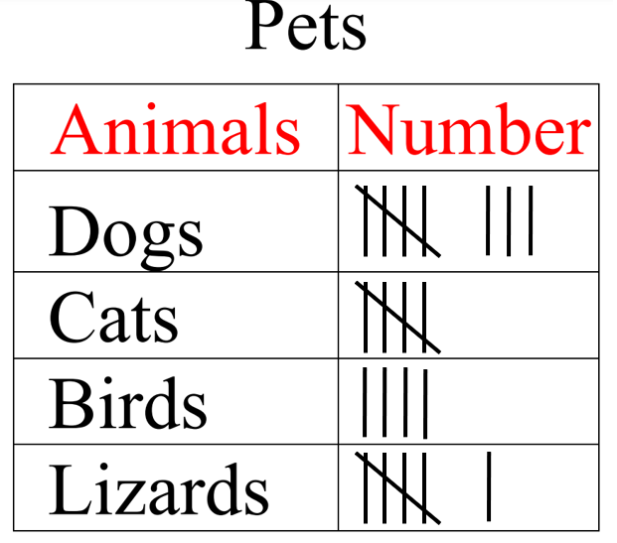

* When data are presented in an organized manner, students can interpret and discuss the results and implications of their investigation (e.g., identifying parts of the data that have special characteristics, including categories with the greatest, the least, or the same number of responses).
* Object graphs are graphs that use concrete materials to represent the categorical data that are collected (e.g., cubes stacked by the month, with one cube representing the birthday month of each student). An object graph includes a title and labeled categories. Each concrete object should represent one data point. Object graphs can be used to make comparisons between categories.
* Picture graphs are graphs that use pictures to represent and compare information. A picture graph includes a title and labeled categories. At this level, each picture should represent one data point (see example below). Picture graphs can be used to make comparisons between categories.

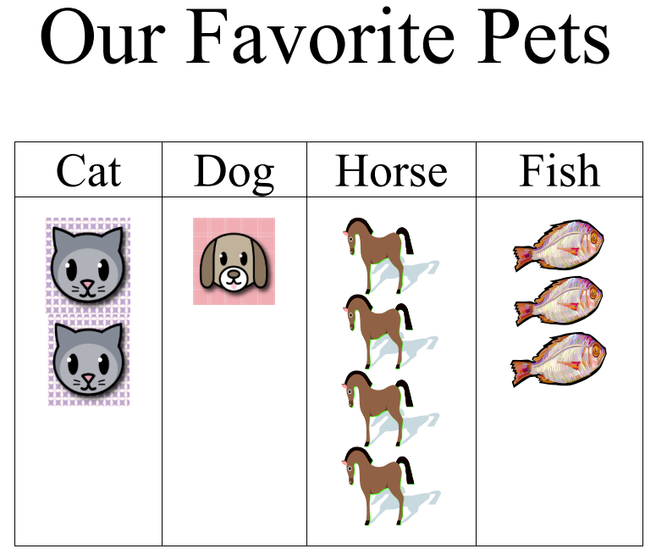

* Tables are an orderly arrangement of data organized in columns and rows. Tables may be used to display some type of numerical relationship or organized lists.
* At this level, data gathered and displayed by students should be limited to 25 or fewer data points for no more than four categories.
* Opportunities to interpret graphs, created with the assistance of the teacher, that contain data points where the entire class is represented (e.g., tables that show who brought their lunch and who will buy their lunch for any given day, picture graph showing how students traveled to school – bus, car, walk) are needed and should continue throughout the school year.
* When drawing conclusions about the data, teachers should pose questions such as, “*What might happen? What will happen? What will not happen?*”
* The data cycle can be used to make connections between mathematics and other disciplines including English, social studies, or science.
  + Sample Connections to English Standards of Learning
    - Who is your favorite author?
    - What is your favorite story that was read in class?
  + Sample Connections to History and Social Science Standards of Learning
    - How do you demonstrate good citizenship?
    - What is your favorite holiday?
    - Taking part of the voting process when making classroom decisions
  + Sample Connections to Science Standards of Learning
    - Graph daily weather conditions
    - Sort animals based on a specific characteristic (e.g., those with fur and those without fur)

###### Skills in Practice

While the five process goals are expected to be embedded in each standard, the Skills in Practice highlight the most prevalent process goals in relation to the content presented.

**Mathematical Communication:** As Grade 1 students engage in the data cycle, they will likely struggle to pose questions that require the collection of data. Teacher support will be necessary to help students distinguish between questions that require data to answer and questions that do not require data to answer. For example, *“Do we have art class today?”* is a question that does not require data to answer; the answer is simply yes or no. Questions that require the collection of data could include anything that involves surveying other students, measuring, or counting and quantifying amounts (see examples below).

* Question that requires surveying: What is your favorite activity to do during recess?
* Question that requires measuring: How much rain did we get each day this month?
* Question that requires counting and quantifying: How was the weather this month (sunny, rainy, cloudy)?

**Mathematical Reasoning:**

* If students are unable to sort objects into two groups, they may need a prompt to help them focus on an object’s attributes. The following questions will help students consider similarities and differences between objects –
  + What object is this?
  + Can you describe this object?
  + What is the same and what is different about these two objects?
* If students still struggle to sort a set of objects, limiting the number of objects to sort or providing a graphic organizer (e.g., Venn diagram) will be beneficial.
* A common error is for students to inaccurately sort objects according to multiple characteristics. These students will benefit from sorting concrete objects that may provide additional visual characteristics (e.g., color, height, weight). The Venn diagram below demonstrates how to sort a set of shapes based on two characteristics, shape (triangles) and color (yellow).

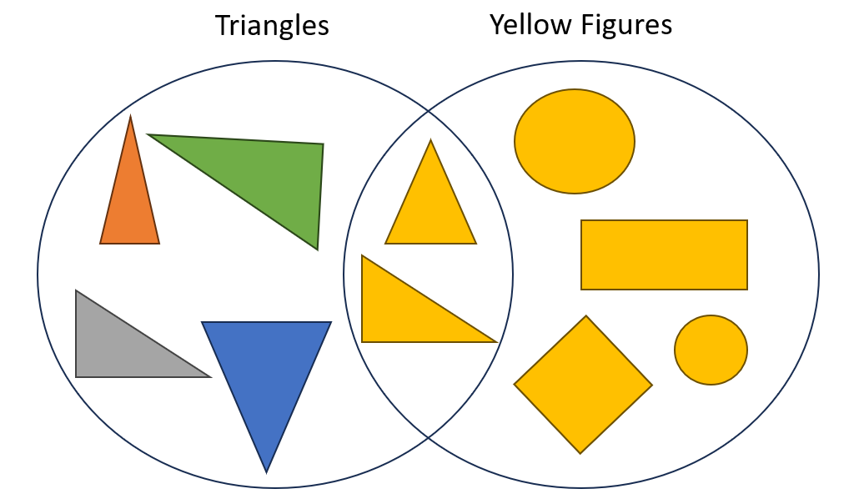

* **Mathematical Representations:** As students move from a concrete representation of data in an object graph to a pictorial representation of data in a picture graph, some students may have difficulty representing the data accurately. They may try to make boxes or create a bar graph instead of a picture graph. If students are responsible for drawing their own pictures, they may struggle to make each picture the same size, resulting in a misleading picture graph.

###### Concepts and Connections

Concepts

Investigating the world through posing questions, collecting data, organizing and representing data, and analyzing data and communicating results can be used to describe and predict events and real-world phenomena.

Connections

* *Within the grade level/course*:
  + 1.MG.2 – The student will describe, sort, draw, and name plane figures (circles, triangles, squares, and rectangles), and compose larger plane figures by combining simple plane figures.
  + 1.CE.1 – The student will recall with automaticity addition and subtraction facts within 10 and represent, solve, and justify solutions to single-step problems, including those in context, using addition and subtraction with whole numbers within 20.
* *Vertical Progression*:
  + K.PS.1 – The student will apply the data cycle (pose questions; collect or acquire data; organize and represent data; and analyze data and communicate results) with a focus on object graphs and picture graphs.
  + 2.PS.1 – The student will apply the data cycle (pose questions; collect or acquire data; organize and represent data; and analyze data and communicate results) with a focus on pictographs and bar graphs.

Across Content Areas [Theme – Graphing]

* *Science*: Depending on the data collected in an investigation, students may use graphs to visualize the data.
  + 1.1c – The student will organize and represent various forms of data using tables, picture graphs, and object graphs; and read and interpret data displayed in tables, picture graphs, and object graphs, using the vocabulary more, less, fewer, greater than, less than, and equal to.
* *Computer Science*:
  + 1.DA.2 – The student will create representations of data to make predictions and draw conclusions.
    - a) Collect and organize data with or without a computing device.
    - b) Create tables, object graphs, picture graphs, and models using abstraction.

###### Resources to Support Local Curriculum

* A list of approved textbooks and instructional materials is posted on the VDOE [website](https://www.doe.virginia.gov/teaching-learning-assessment/k-12-standards-instruction/mathematics/2024-mathematics-textbooks).
* Data Cycle Teacher Resource ([PPT](https://www.doe.virginia.gov/home/showdocument?id=52067&t=638411641432900000) | [PDF](https://www.doe.virginia.gov/home/showdocument?id=52065&t=638411641427430000))

## Patterns, Functions, and Algebra

In K-12 mathematics, the patterns, functions, and algebra strand focuses on the recognition, description, and analysis of patterns, functions, and algebraic concepts. Students develop an understanding of mathematical relationships and represent these using symbols, tables, graphs, and rules. In later grades, students use models as they solve equations and inequalities and develop an understanding of functions. This strand is designed to develop students’ algebraic thinking and problem-solving skills, laying the foundation for more advanced mathematical concepts.

In Grade 1, students understand that relationships can be described, and generalizations can be made using patterns and relations. At this grade level, students will identify, describe, extend, create, and transfer repeating and growing (increasing) patterns using various representations.

### 1.PFA.1

##### The student will identify, describe, extend, create, and transfer repeating patterns and increasing patterns using various representations.

1. Students will demonstrate the following Knowledge and Skills:
2. Identify and describe repeating and increasing patterns.
3. Analyze a repeating or increasing pattern and generalize the change to extend the pattern using objects, colors, movements, pictures, or geometric figures.
4. Create a repeating or increasing pattern using objects, pictures, movements, colors, or geometric figures.
5. Transfer a repeating or increasing pattern from one form to another.

###### Understanding the Standard

* Patterning is a fundamental cornerstone of mathematics, particularly algebra. The process of generalization leads to the foundation of algebraic reasoning.
* Opportunities to identify, describe, extend, create, and transfer patterns are essential to the primary school experience and lay the foundation for algebraic thinking.
* Patterning should include:
  + creating a given pattern using objects, sounds, movements, and pictures;
  + describing a pattern, to include identifying the core of the pattern and labeling the pattern;
  + recording a pattern with pictures or symbols;
  + transferring a pattern into a different form or different representation (e.g., blue–blue–red–green to an AABC repeating pattern); and
  + analyzing patterns in practical situations (e.g., calendar, seasons, days of the week).
* In a repeating pattern the part of the pattern that repeats is the core. In the example below, the core is smiley face, heart, heart, lightning bolt.

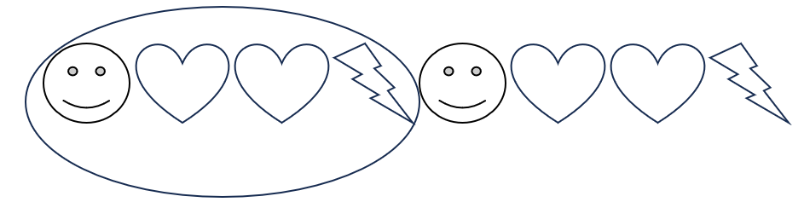

* At this level, experiences extending patterns when given a complete repetition of a core (e.g., ABACABACABAC) as well as when the final repetition of the core is incomplete (e.g., AABBAABBAA …; Red, Blue, Green, Red, Blue, Green, Red, Blue...) will deepen understanding of repeating patterns.
* Examples of repeating patterns include:
  + AABCAABC;
  + ABACABAC;
  + ABBCABBC;
  + AABCAABC; and
  + ABACDABACD.
* Transferring a pattern is creating the pattern in a different form or representation. Examples of pattern transfers include:
  + ABABAB… has the same structure as red, blue, red, blue, red, blue;
  + Snap, clap, jump, clap, snap, clap, jump, clap has the same structure as ABCBABCB…; and
  + Pattern showing one smiley face, one star, one smiley face, two stars, one smiley face, three starshas the same structure as ABABBABBB....
* Growing patterns involve a progression from term to term, which make them more challenging for students than repeating patterns. Growing patterns can increase or decrease. Determining what comes next begins the process of generalization, which leads to the foundation of algebraic reasoning. Experiences identifying what changes and what stays the same in a pattern fosters algebraic thinking. Patterns may be represented in various ways, including numerically, or using dot patterns, staircases, pictures, etc.
* In Grade 1, growing patterns will be limited to increasing values.
* Examples of increasing patterns include:
  + 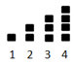
  + A pattern showing one star, one triangle, two stars, two triangles, three stars, three triangles, one triangle ...
  + **5, 10, 15, 20…**

###### Skills in Practice

While the five process goals are expected to be embedded in each standard, the Skills in Practice highlight the most prevalent process goals in relation to the content presented.

**Mathematical Reasoning:** Students may struggle to complete a repeating pattern that contains more than two different elements or contains elements of varying numbers. For example, given the pattern below, students may incorrectly say that the triangle comes next. This may indicate that students are unable to identify the core of the pattern, or they may not have paid close attention to the two stars in the core. Students may benefit from being instructed to circle or underline the core of the pattern. Additionally, students may benefit from coloring the pattern (i.e., all stars one color, all triangles another color, all squares a third color), which will allow them to see the color pattern and help them to visualize what comes next.



**Mathematical Representations:** Transferring patterns from one representation to another is an expectation in Grade 1. Students who are unable to transfer patterns need additional opportunities to collaborate with classmates to describe and analyze patterns and then represent those same patterns in different forms. Transferring patterns becomes easier for students once they can identify the core and extend patterns.

###### Concepts and Connections

Concepts

Relationships are described and generalizations are made using patterns, relations, and functions.

Connections

* *Within the grade level/course*:
  + 1.NS.1 – The student will utilize flexible counting strategies to determine and describe quantities up to 120.
  + 1.MG.2 – The student will describe, sort, draw, and name plane figures (circles, triangles, squares, and rectangles), and compose larger plane figures by combining simple plane figures.
* *Vertical Progression*:
  + K.PFA.1 – The student will identify, describe, extend, and create simple repeating patterns using various representations.
  + 2.PFA.1 – The student will describe, extend, create, and transfer repeating and increasing patterns (limited to addition of whole numbers) using various representations.

Across Content Areas [Theme – Numbers, Number Sense, and Patterns]

* *Science:*
  + 1.6a,b – The student will use observations of the sun to describe patterns that can be predicted.
  + 1.6b – The student will observe where the sun rises in the morning and sets in the evening and describe the pattern.
* *Computer Science*:
  + 1.AP.1 – The student will apply computational thinking by sorting items into categories based on multiple attributes and create patterns.
    - a) Describe attributes of a set of objects.
    - b) List the attributes a set of objects have in common.
    - c) Sort and classify concrete objects based on multiple attributes.
    - d) Create repeating and increasing patterns.
  + 1.DA.2 – The student will create representations of data to make predictions and draw conclusions.
    - c) Identify patterns and describe trends in data visualizations of various formats.
    - d) Use data to answer questions, draw conclusions, and make predictions.

###### Resources to Support Local Curriculum

* A list of approved textbooks and instructional materials is posted on the VDOE [website](https://www.doe.virginia.gov/teaching-learning-assessment/k-12-standards-instruction/mathematics/2024-mathematics-textbooks).